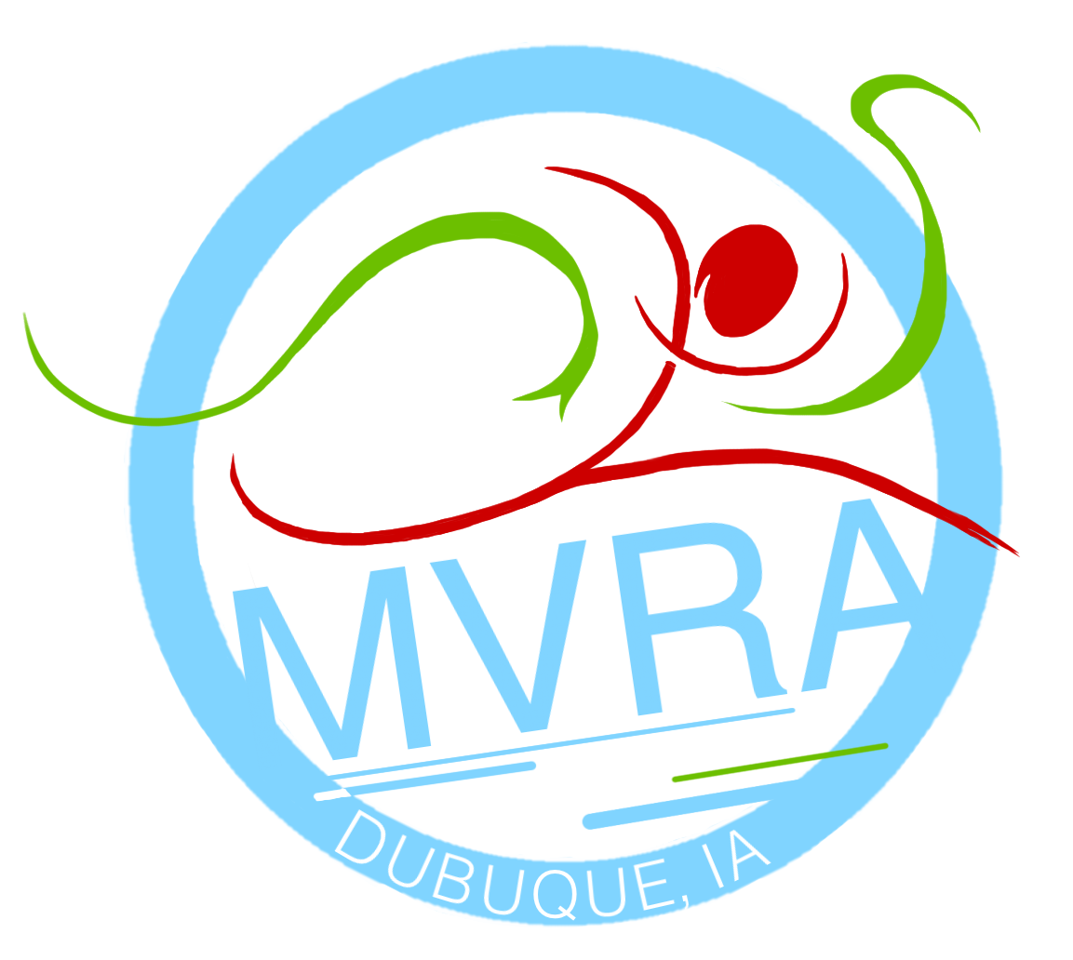
Business Membership
Annual Costs: $250
Make checks payable to: MVRA

Don’t wish to be a member, but want to help?
___ $25 ___ $50
___ $100 ___ other amount

Questions? Contact Rob Harbin
rtharbin33@gmail.com

The Mississippi Valley Running Association is dedicated to building the
tri-state running community through races and fun runs. We then use proceeds from our races to give back to the community through annual charitable donations and scholarships. By partnering with the MVRA as a business member you allow us to continue to support running, health and fitness in the tri-state area.
WHAT YOU WILL GET AS A BUSINESS MEMBER
- Race booth at the following MVRA events
  - Heritage Trail 5K/10K – May 11th
  - Grandview Gallop 4 Mile – June 15th
  - Dubuque Benefit Classic Half Marathon/5K – Sept 14th
  - Iowa Games 5K – January 2020
- Logo on the back of the Heritage Trail and Benefit Classic race shirts
- Three race entries to the MVRA race of your choice ($90-$135 value)
- Three MVRA memberships ($45 value)
- Logo on MVRA website with clickable link

Thank you for your support!
NAME: _______________________________________

COMPANY: ___________________________________

ADDRESS: ____________________________________

PHONE: ______________________________________

EMAIL: _______________________________________

Fill out form and send to:
rtharbin33@gmail.com
or
MVRA Business Membership
PO Box 854
Dubuque, IA 52004-854

2019 MVRA
Business Membership

